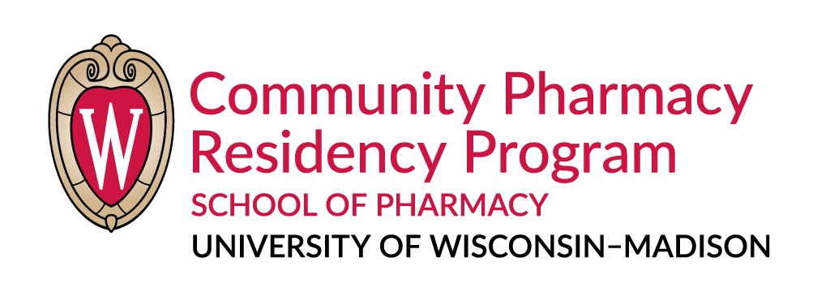
APPLICATION FOR RESIDENCY APPOINTMENT

Name:
Last First Middle
Email:

Present Telephone: ( )
Address Street City State Zip

Permanent Telephone: ( )
Address Street City State Zip

Date of Birth: Birthplace: Citizenship:

References
Letter of recommendations have been requested from the following individuals and will arrive under separate cover.

1.
Name Position Organization City, State

2.
Name Position Organization City, State

3.
Name Position Organization City, State
Licensure Status
Current:
State: Certificate No.: Date Granted:

State: Certificate No.: Date Granted:

We are a multisite community residency program. Applicants pay one fee to interview at one or more of our sites. Please indicate which site(s) you are interested in interviewing with:

_____ Boscobel Pharmacy
_____ Forward Pharmacy
_____ Hayat Pharmacy
_____ Reedsburg Area Medical Center – Viking Pharmacy

(continued on next page)

Application Packet – Submit via PHORCAS
The following materials are required to complete your application:
Completed application form (this form)
One-page letter of interest explaining how this program will help you meet your career goals
Curriculum Vitae (CV) (most current)
Official copy of Pharmacy College/University transcript(s)
Three letters of recommendation or Recommendation Request forms

I hereby confirm that the information that I have included in this application packet is accurate and up to date.

Signature Date

Submit application packet by January 1, 2024, via PHORCAS.

Questions? Contact:
Mara A. Kieser, MS, RPh.
Residency Program Director - UWCPRP
777 Highland Avenue, Room 1020
Madison, Wisconsin 53705-2222
mara.kieser@wisc.edu
(608) 262-6168

