PLAN-DO-STUDY-ACT (PDSA)
CRITICAL QUESTIONS
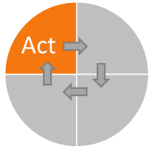
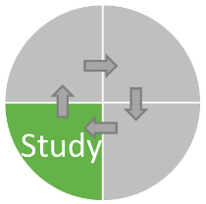
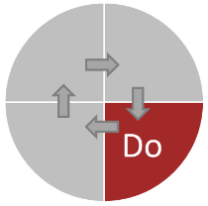
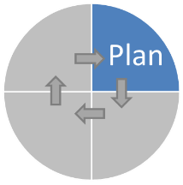

PLAN
- What is your Goal?
- What will you test and how will you test it?
- What questions are you trying to answer with this test?
- What do you expect will happen and why?
- How will you measure the results of this test?
- What data will you need to collect?
- Where will you collect the data? (What service/ clients?)
- When will you collect the data? (Start and stop date?)
- How will you collect the data?
- Who will collect the data?

DO
- What are you learning as you go?
- What is going well?
- What problems have you had with the test?
- What has reprised you?
- What problems have you had collecting data?
- What is the data showing?

STUDY
- What does the data tell you?
- What issues arose during the Do phase?
- How do the results compare to your prediction?
- What have you learned?

ACT
- What did you learn from the study?
- Did you experience problems?
- Did you achieve your goal? (In part? In full?)
- If full achievement, are you ready to adopt?
- If partial, are you ready to adapt? (Next cycle ideas?)
- If failed, are you ready to abandon? (Consider a different test?)

