FLOWCHARTS
A visual map of the process, designed to show steps and transitions, is helpful for finding bottle necks, roadblocks and other challenges that prevent a smooth flow in the service process. These challenges are excellent targets for improvement.
Steps
Flaws

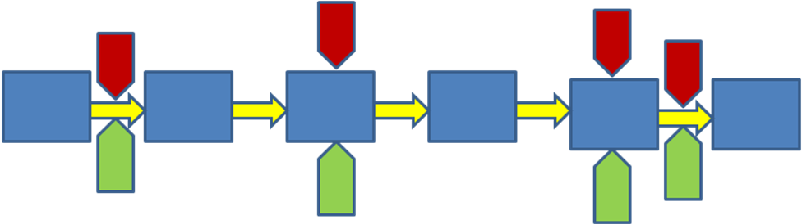
Transitions
Fixes

Step 1: Draw the first and last step of the process you would like to flowchart.
Step 2: Fill in all the steps of the process (this can include decision steps by using diamonds).
?
NO

YES

Step 3: Note any laws to the process: This step has elements that people complain about, this transition takes too long and leaves people waiting, etc. (Remember that flaws can be located in the steps and/or in the transitions.)
Tip: draw the steps on Post-it notes so that you can move them around as needed.

Step 4: Note any Fixes for the Flaws you have defined.
Step 5: Use the flowchart along with other tools to consider next steps for improvement projects.

