CAUSE & EFFECT DIAGRAM
Also known as the fishbone or the Ishikawa diagram, the Cause & Effect Diagram is used to explore the root cause of a problem. Traditionally done in the shape of a fish, the facilitator asks a group to consider a problem, and then asks for the causes of the problem, and the causes of the causes, until all potential root causes have been explored.
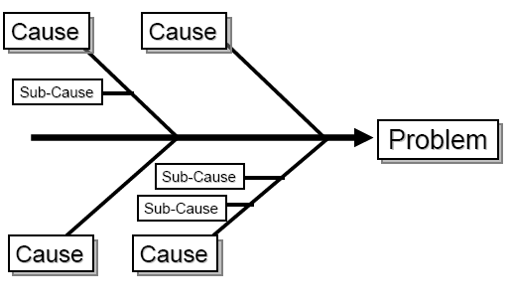
Others prefer a hub and spoke approach, as it is easier to draw and expand with a group:
- Define the problem in a center circle and then draw a cause circle at each of the 4 compass headings.
- Ask the group to define at least these 4 causes (there may be more) and place them in the circles.
- Explore the sub causes of these 4 causes and continue until all causes have been explored.
The result will be an inventory of granular root causes, some of which will be excellent targets for improvement.

Cause & Effect Diagram

C
C

C
C
C
C
C
C
C
C
C
C
C
C
C
C
C
C
C
C
C
C
C
C
C
C
C
Cause
Cause
Cause
Cause
Problem
C

Why don't people show up for the appointment?
They forget, they are ambivalent, they feel stigma, they don't have transportation...

Why don't they have transportation?
They have no car, they are socially isolated, they don't use the bus...

Why don't they use the bus?
The bus is confusing, the bus costs too much, the bus schedule is inconvenient, they have children.

So now we have moved from "Let’s fix the no show problem", to "Let’s do bus training, or provide bus tokens"... A much more actionable agenda.

