Vivitrol Treatment Informed Consent Form

I agree to receive Vivitrol treatment and I understand that once Vivitrol is injected, it is not possible to remove it from my body.

Alcohol dependence: I understand that I am required to not have used alcohol or alcohol containing products for the past 4 days and that I am not currently using any alcohol products

Opioid dependence: I understand that I am required to be opioid-free for at least 7-10 days before starting Vivitrol, that I am not currently taking opioids, and that if I am not detoxed, the Vivitrol injection will precipitate immediate and sometimes severe opioid withdrawal.

I understand the risks associated with using Vivitrol while pregnant.

I understand that if I have previously used opioids, I may be more sensitive to lower doses of opioids and at risk of accidental overdose if I use opioids when my next dose is due, if I miss a dose, or after Vivitrol treatment is discontinued. It is important that I inform family members and people close to me of this increased sensitivity to opioids and the risk of overdose.

I understand that a reaction at the site of Vivitrol injection may occur. Reactions include pain, tenderness, induration, swelling, redness, bruising and itching. Serious injection site reactions including tissue death may occur. Some of these injection site reactions have required surgery. I should seek medical attention for worsening skin reactions.

I understand that Vivitrol may cause liver injury and I need to notify my healthcare provider if I develop symptoms and or signs of liver disease.

I understand that I may experience depression while taking Vivitrol. It is important that I inform family members and people close to me that I am taking Vivitrol and that they should call a doctor right away if I become depressed or experience symptoms of depression.

I understand that Vivitrol may cause an allergic pneumonia. I should immediately notify my physician if I develop signs and symptoms of pneumonia, including shortness of breath, coughing or wheezing.

I have read and understand all the information about Vivitrol treatment. I have received answers to any questions I have.

Patient Signature: Date:
- Pharmacist Signature: _______________________________________ Date:

Pharmacy:
Lot/Exp. Date of Product Administered:
Location of Injection: R or L (circle one) gluteal muscle

Vivitro1 Pre-Injection Verification Questions for Patients

Place Rx Label Here

Have you used (or tried) any opioid or other drug(s) since your last visit (prescribed or not)?
If yes, please list

Must be clean for 7-14 days (minimum) to avoid severe withdrawal symptoms. If not, we will not administer.

Have any feelings of depression worsened during the last month? If yes, explain below.

FEMALES: Currently on a form of birth control? Yes/ No _ Pregnancy test negative confirmed with patient Yes/ No
Pregnancy test supplied/ offered to patient Yes/No

- .... ---- . ··..
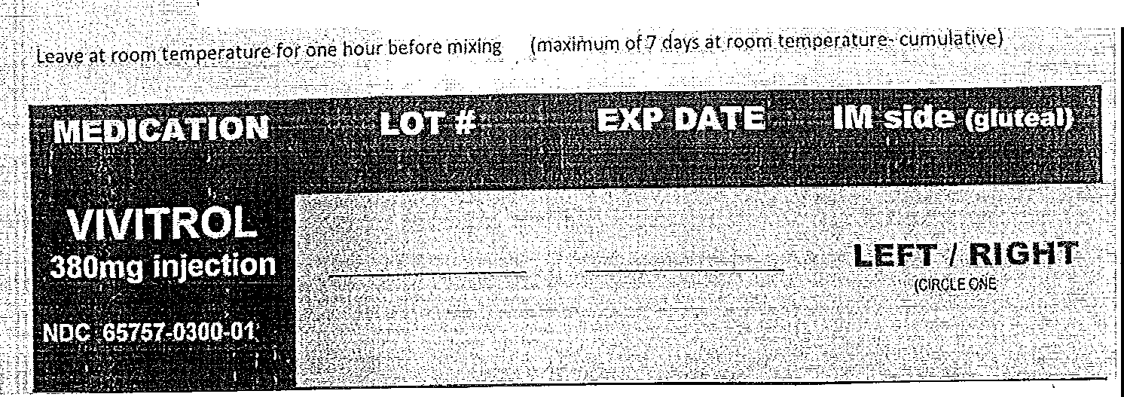
VIVITROL 380MG INJECTION NDC 65757-0300-01
.

Patient Signature ______________________________________ Date ______

Pharmacist Signature ___________________________________ Date ______

Scan into Pioneer Fax prescriber a notification of administration

OMRO PHARMACY CONFIDENTIAL FORM
Appendix B: Introduction to the Risks of Extended-Release,
Injectable Naltrexone Worksheet
Extended-Release, Injectable Naltrexone Patient Handout What is extended-release, injectable naltrexone?
It is a monthly shot that may help you to stop or reduce your alcohol use, usually combined with counseling and support.

Important: Please tell your doctor before you start treatment if ...
  - You use drugs (for example, morphine, Vicodin, methadone, Suboxone, oxycodone, heroin)
- Do NOT use drugs during treatment or for the first two to three weeks after stopping treatment; it may result in an overdose
  - You are going to have surgery or medical treatment that may include pain medications
  - You have any liver disease(s)
  - You are pregnant, intend to get pregnant, or are breastfeeding
- You should NOT get any treatment shots if you are pregnant or breastfeeding

Side effects and complications of extended-release, injectable naltrexone
  - The most common side effect is mild nausea, which usually goes away within days after the shot
  - You may experience a little pain at the location of the shot
o You may use over-the-counter pain medications, such as Tylenol or Advil
  - You may feel sad; if you have thoughts about hurting or killing yourself, notify your doctor RIGHT AWAY
  - Some may experience an allergic reaction
  - It may harm your liver or cause hepatitis in some individuals

Notify your doctor RIGHT AWAY, if ...
  - you have bad pain at the site of the shot
  - the location of the shot feels hard, there is a bump or blister, or is red there is an open cut at the site of the shot
  - you have stomach pain lasting longer than a few days you have dark urine
  - the area around your eyes is yellow
  - you feel really tired
  - you are having a hard time breathing
  - you are coughing and it does not go away you have a skin rash
  - swelling of your face, eyes, mouth, or tongue happens you feel chest pain
  - you feel dizzy or weak

If you experience any side effects or complications, please contact your doctor immediately at
  - Venice Family Clinic: (310) 392-8636
  - The call center is open Monday through Thursday, 8:00 a.m. to 5:00 p.m. and Friday 8:00a.m. to 4:00 p.m.

